MINISTRY OF EDUCATION AND TRAINING
HO CHI MINH CITY UNIVERSITY OF FOREIGN LANGUAGES ​​- INFORMATION TECHNOLOGY

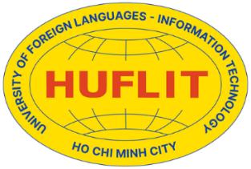
TRƯƠNG VĂN TUYNH

A CLASS OBSERVATION OF ENGLISH AS A MEDIUM OF INSTRUCTION AT FACULTY OF FOREIGN LANGUAGES AT HUFLIT

(Ghi chú: trang này là bìa mạ vàng)

MASTER’S FINAL PROJECT
MAJOR: ENGLISH LANGUAGE STUDIES
COURSE CODE: 8220201
ID: MES23131

HO CHI MINH CITY
2026
MINISTRY OF EDUCATION AND TRAINING
HO CHI MINH CITY UNIVERSITY OF FOREIGN LANGUAGES ​​- INFORMATION TECHNOLOGY

TRƯƠNG VĂN TUYNH

A CLASS OBSERVATION OF ENGLISH AS A MEDIUM OF INSTRUCTION AT FACULTY OF FOREIGN LANGUAGES AT HUFLIT

(Ghi chú: trang này là trang trắng tiếp theo)
MASTER’S FINAL PROJECT
MAJOR: ENGLISH LANGUAGE STUDIES
COURSE CODE: 8220201
ID: MES23131
Supervised by
TRẦN VŨ DIỄM THÚY, PhD.
and
TRẦN QUANG BẢO PHÚC, PhD.

A Final Project Submitted in Partial Fulfilment of the Requirements
for the Degree of Master of Arts in English Language Studies
HO CHI MINH CITY
2026

Nội dung phần gáy:

TRƯƠNG VĂN TUYNH MASTER’S FINAL PROJECT 2026

